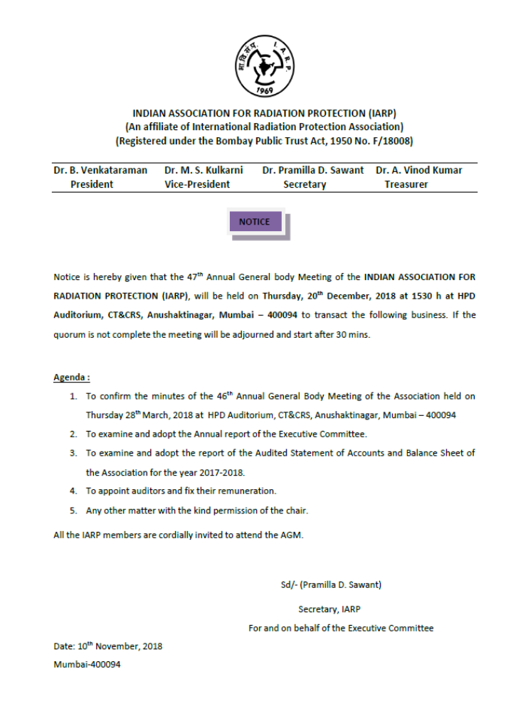

INDIAN ASSOCIATION FOR RADIATION PROTECTION

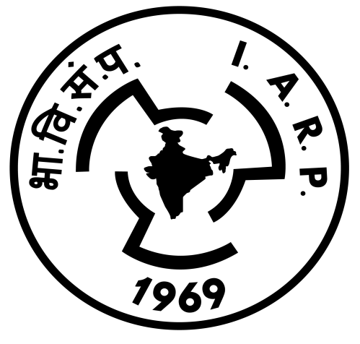

ANNUAL REPORT
2017-2018

10-11-2018
Annual Report of the IARP for the year 2017-18

Dear Members
The Indian Association for Radiation Protection (IARP) Executive Committee conveys greetings to all members. During the period 2017-18, the IARP continued its activities such as organizing extensive training programmes related to safety in applications of radiation and radioisotopes in industry, nucleonic gauges, holding of international conference, birth centenary year celebration of Dr. A. K. Ganguly, public awareness programmes, seminar, executive committee meetings, publication of “Radiation Protection and Environment” journal etc. These activities are briefly outlined here.

1. The IARP’s ‘Radiation Protection and Environment’ (RPE) journal:
Publication of Radiation Protection and Environment (RPE), the quarterly journal of IARP was continued with the able help of the RPE Editorial Board. The printing and distribution of the journal to the IARP life members has been entrusted to M/s. Wolters & Kluwer India Pvt. Ltd. publications. The process of submission of manuscripts, peer review process, revision of articles, status of acceptance etc., are completely on-line and handled by M/s. Wolters & Kluwers India Pvt. Ltd. In order to ensure, easy access, the RPE journal has been made available on-line. It was decided to print about 300 copies of the journal for distribution to interested members who have updated their addresses. Four issues of the Radiation Protection and Environment, Vol. 40 (issues 1-4) were published during the period. Nearly Rs. 4.26 lakhs was spent towards publication of RPE journal issues. The RPE journal current issues and also archives from the year 2010 onwards are available on-line at the site: www. journalonweb.com/rpe.
The Executive Committee of IARP and the Editorial Board would like to place on record its appreciation to the retired and serving experts from DAE facilities, universities and from abroad, who have contributed to the journal in terms of peer reviewing of the papers. Senior members of the IARP who would like to serve as reviewers may register themselves at the site: www.journalonweb.com/rpe.
All IARP members and the readers are requested to contribute to the journal in terms of original papers, reviews, and materials for publication in News and Information Section of the journal. The submission of manuscripts for publication in the journal can be done online (www. journalonweb.com/rpe). A link to the journal can also be found at IARP website www.iarp.org.in
- Financial Support
IARP provided financial assistance of Rs. 30,000/- to Navi Mumbai Science Foundation for conducting a half day seminar on “World Nuclear Day – 2016” on 2nd of Dec 2017, the anniversary of the first criticality of the first reactor constructed by the famous American Scientist Enrico Fermi. The program was jointly organized by Navi Mumbai Science Foundation (NMSF), Karmaveer Bhaurao Patil College (KBPC) in association with the Maharashtra Academy of Sciences and IARP supported it as a part of its public awareness program. On behalf of IARP, Dr. S. D, Sharma, delivered a lecture on radiation safety in nuclear fuel cycle operations. Members of IARP arranged demonstration of radiation measuring instruments and safety equipment for the benefit of participating students.
- 33rd IARP International Conference : IARPIC-2018
IARP organized a five day International Conference (IARPIC-2018) during January 16-20, 2018 at DAE Convention Centre, Anushaktinagar, Mumbai. The theme of the conference was “Developments towards Improvement of Radiological Surveillance at Nuclear Facilities and Environment”. The conference was inaugurated by Shri. S. A. Bhardwaj, Chairman, Atomic Energy Regulatory Board (AERB) and Dr. Roger Coates, President, International Radiation Protection Association (IRPA), was the guest of honour. Dr. Roger Coates in his address mentioned the existence of impressive talent pool of Indian radiation protection professionals and the need of their increased contributions internationally and to IRPA. He hoped for a successful interaction of delegates with the experts from ICRP, IAEA, UNSCEAR and other professional bodies.
Dr. M.S. Kulkarni, Secretary, IARP welcomed the delegates, research scholars and professors from universities and other institutes and briefed them about IARP activities and the IARPIC-2018 conference. He spoke about IARP and it’s affiliation to IRPA. Dr.Pradeepkumar K. S., President IARP and Associate Director, Health, Safety & Environment Group, BARC addressed the delegates to the conference and briefed on the technical programme of IARPIC-2018.
The conference was attended by about 400 scientists, including Radiation Protection professionals from various DAE institutions, students and professors from universities and Radiation Safety Officers (RSO) of Hospitals and Industry. Scientific Secretary, Chairs of ICRP committees, President, IRPA, Former Chairman, UNSCEAR; Experts from National Nuclear Security Administration, USA delivered invited talks and participated in the discussions during the conference.
The scientific deliberations of the IARPIC-2018 conference included latest developments in radiological surveillance at nuclear facilities and environment, assessment of radiation exposure to the public from natural radiation, environmental radioactivity, radiation dosimetry, nuclear forensics and emergency preparedness. The conference deliberations included 24 invited talks, 36 oral presentations and 265 poster presentations. There were several invited talks on the work carried out internationally by the speakers from abroad, notably on the radiation effects by Dr. Werner Ruum, Chair of ICRP Committee 1, Dr. Christopher Clement, Scientific Secretary, ICRP, on ICRP activities, Dr. Abel J. Gonsalez, former chairman UNSCEAR, on the scientific background for dose limits of radiation for workers and public, Dr. Roger Coates, President IRPA, on the radiation protection culture in Nuclear Facilities, Dr. Daniel J. Blumenthal from USDOE, USA on structure and implementation of emergency preparedness procedures; Dr Musolino of USDOE on the communications with public and professionals from other than radiation industry.
A panel discussion on ‘Radiation protection of workers and addressing concerns on radiological safety’ on the concluding day of conference was well received by the delegates. The panelists included Dr. Abel J. Gonsalez (UNSCEAR), Dr. Roger Coates (IRPA), Dr. Christopher Clement (ICRP), Dr. Werner Ruum (ICRP), Dr. K. Highley (ICRP), Dr. V. Berkovskyy (ICRP), Dr. Pradeepkumar K.S. (BARC), and Shri S. Krishnamony (ex. BARC), Daniel Blumenthal (USDOE).
IARP awards for the year 2018 have been bestowed on meritorious scientists during the inaugural session. The awardees are: 1) Dr. M. R. Iyer, for Dr. A.K. Ganguly Birth Centenary Lifetime Achievement Award; 2) Dr. Y. S. Mayya for “Dr. K.G. Vohra Memorial Oration Award”; 3) Dr. S. R. Vadera, DLJ for “Shri A. Nagaratnam Memorial Oration Award”; 4) Dr. P. C. Kesavan for “Dr. A.K. Ganguly Memorial Oration Award”; 5) Shri. J. P. N. Pandey for “Meritorious Operational Health Physics award”; 7) Dr. V. N. Jha for “Meritorious Radiological Safety Officer Award”; 8) Shri. Senthil Kumar for “Meritorious Radiological Safety Officer Award”; 9) Shri. P. Amaty for “Meritorious Radiological Safety Officer Award”; 10) Shri. A. Baburajan for “Shri P.R. Kamath Radiation Environmentalist Award”. Best paper in RPE Journal award in the name of “Dr. D. V. Gopinath” was given to Dr. Munish Kumar. In addition, best oral and poster papers were also bestowed on the authors during the concluding session.
Dr. Iyer donated the award money (Rs 50,000/-) to the IARP with a request to institute an award for the best paper in RPE on radiation protection or to the best essay on "Atomic energy and environment" by students from universities which are closely associated in environmental surveillance. He has requested to give the award in the name of "Dr. Ganguly Environmental Award" during the biannual IARP conferences.
- Dr. A. K. Ganguly Birth Centenary Year Celebrations
IARP also celebrated its Golden Jubilee year and Dr. A.K. Ganguly (the founder of Health Safety Programme in India) Birth Centenary Year during the conference. Dr. A.K. Ganguly Birth Centenary programme was arranged at Vashi (Navi Mumbai) on first day of the conference at 4 p.m. and was inaugurated by Dr. Anil Kakodkar, Former Chairman, Atomic Energy Commission. The highlight of these celebrations was the release of book of “Compendium on memoirs of Dr. A.K. Ganguly” and “Nostalgia of footprints of Dr. A.K. Ganguly Photo Album”. The books are available on-line on the IARP website www.iarp.org.in. These celebrations were marked by the presence of former colleagues and students of Dr. A.K. Ganguly (fondly known as Ganguly School), the contributors to the book of compendium, former Directors of HS&EG, former Heads of Divisions of HS&EG, a few former members of IARP EC and the family members of Dr. A.K. Ganguly. The family members of Dr. A.K. Ganguly, former colleagues of Dr. A.K. Ganguly and Directors & Heads of Divisions of HSEG were felicitated on the occasion. The total expenditure for the conduct of this programme was ~ Rs. 10 lakhs (including TA for senior life members).
- Public Awareness Programme (PAP)

On several instances, concerns on radiation safety and protection of occupational workers & public from radiation are expressed in the media due to lack of awareness. To address this issue, IARP has been conducting public awareness programmes (PAP) all over India to place facts on nuclear safety and remove myths about ionizing radiation. In continuation of this effort, IARP has carried out the two public awareness programmes at colleges in Maharashtra state during 2017-2018.

- A two day programme on “Radiation Safety, Detection and Applications” was arranged at the M.D. College, Department of Physics, Parel, on December 15-16, 2017. Five lectures were delivered during this program. The topics of the talk were Fundamentals of atomic energy, Radiation and Environment and Applications of nuclear energy for the benefit of humankind. Dr. K. P. Muthe, Shri. Yatin Thakur and team presented an innovative Skit "Kum mai hai dum" which was one of the attractions of the workshop. Radiation Monitoring Instruments were demonstrated in batches to all the students. The workshop was also attended by both Undergraduate and Postgraduate students (150 nos) and teachers of nearby colleges.

- A one day Public awareness programme on “Peaceful Applications of Radiation” was organized at Mahatma Gandhi College, Loni, Pravaranagar, Maharashtra on 15th March, 2018. The lectures included “Fundamentals of Atomic Energy, Radiation and Environment”, “Applications of nuclear energy for the benefit of humankind”. Radiation Monitoring Instruments were demonstrated in batches to all the students. The program was attended by about 200 junior college students.

Nearly Rs. 2.8 lakhs was spent towards organizing the above mentioned PAPs.

- Training Programmes conducted by GCTC, IARP:
Governing Council for Training Courses (GCTC) of IARP continued the training programme in collaboration with the RP&AD, BARC. A total of twelve training courses were conducted during the financial year and the total amount collected towards fees was ~Rs.34L. Expenses towards the training course is shown in the balance sheet. About 419 candidates participated in the various training programs from various institutions and companies attended and completed the courses. The training courses were coordinated by Dr. R. Kannan and Dr. P. K. Gaur with the cooperation with many resource persons taken from serving and retired IARP life members.

TRAINING CALENDER DURING April 01, 2017 – March 31, 2018

Trg No. | Duration | No. Participants
NG-145 | April 17 – 25, 2017 | 48
NG-146 | June 12 – 20, 2017 | 48
NG-147 | August 21 – 29, 2017 | 36
NG-148 | September 04 – 12, 2017 | 45
NG-149 | October 09 – 17, 2017 | 33
NG-150 | November 06 – 14, 2017 | 35
NG-151 | December 11 – 19, 2017 | 42
GIC-03 | January 08 – 16, 2018 | 13
RA-49 | January 22 – 30, 2018 | 25
NG-152 | February 05 – 13, 2018 | 40
NG-153 | February 19 – 27, 2018 | 33
CAL-04 | March 05 – 16, 2018 | 21

A sum of Rs. 4.4 lakhs has been paid as General Service tax for all the courses conducted by IARP during 2017-2018.

- Instruments:
The radiation survey meters in the low, medium and high ranges (eg. µR/h, mR/h and R/h) procured by the IARP Governing Council on Training Program (GCTC) were extensively used in the public awareness programmes and training programmes conducted by GCTC.
- EC meetings:
One EC meeting and a number of meetings of Organizing Committee (IARPIC-2018) which included EC members were conducted during the period 1/4/2017 to 31/3/2018. IARP paid the annual membership fees to IRPA @ $ 1.5 per member for 300 active life members.
9. Acknowledgements:
IARP acknowledges with gratitude the support extended by various units of the Department of Atomic Energy such as, BARC, IGCAR, AERB, NPCIL for supporting various activities of IARP. The Executive Committee of IARP thanks Chairman, Board of Trustees and all the Members of the Board of Trustees for their valuable guidance. The Executive Committee takes this opportunity to thank all members, office bearers, editorial board members, advertisers, sponsors and all those who contributed for the smooth functioning of the Association. It must be mentioned that the IARP has achieved financial self sufficiency through the funds generated by the training courses. Last but not the least a special thanks to each one of you for your interest and participation in all the activities of IARP. We sincerely request your continued support and hope you will encourage us in all the future IARP activities.
 (Pramilla D. Sawant) Secretary, IARP

IARPIC-2018
“Developments towards Improvement of Radiological Surveillance at Nuclear Facilities and Environment”
January 16-20, 2018
DAE Convention Centre, Anushaktinagar, Mumbai

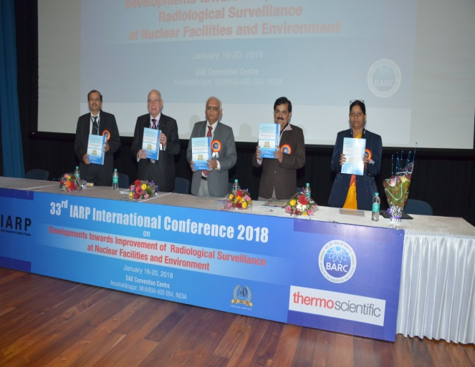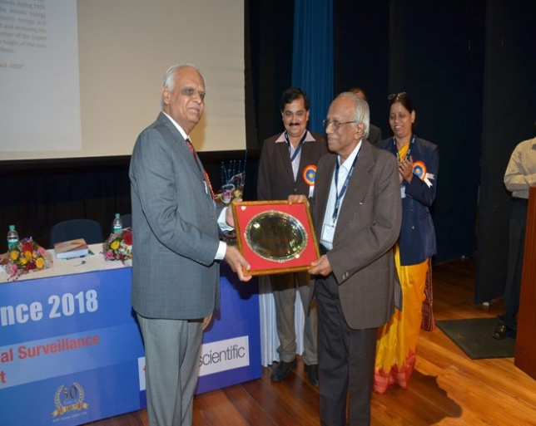

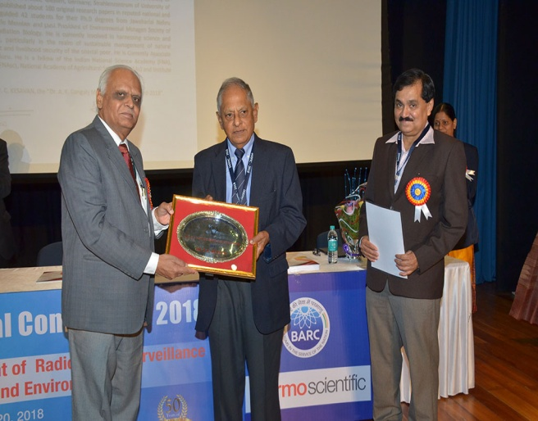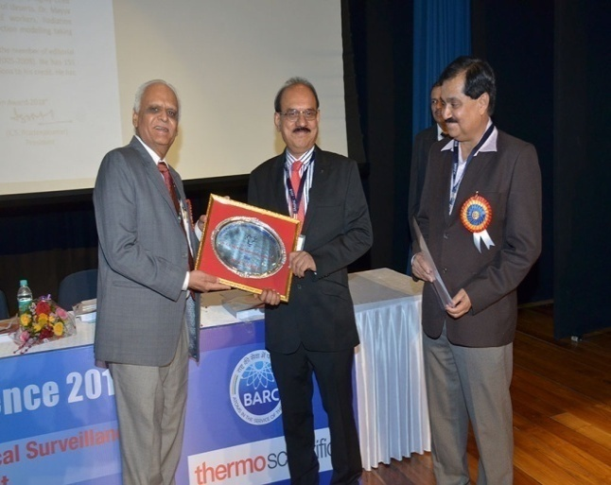

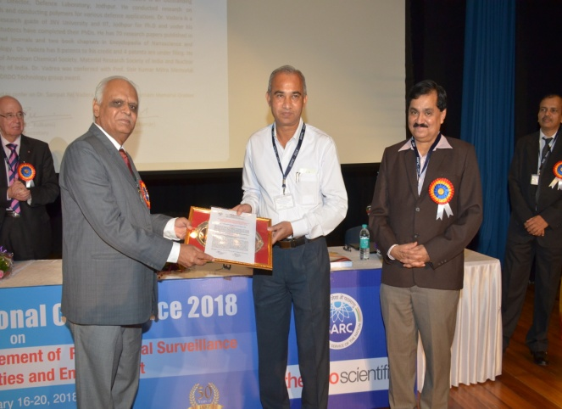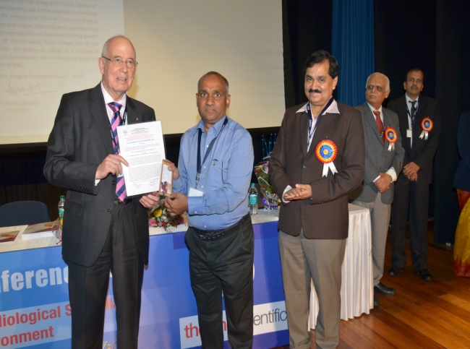

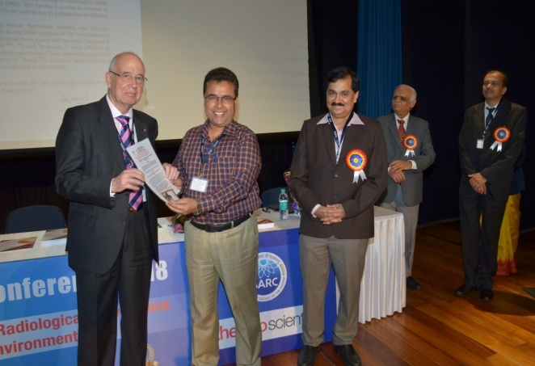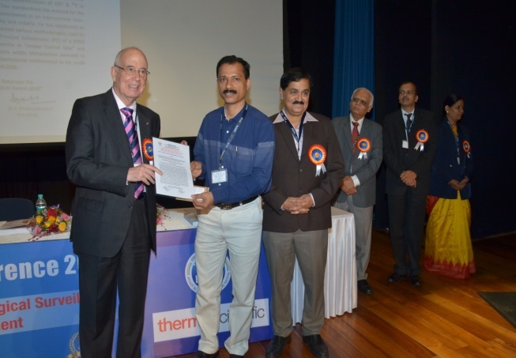

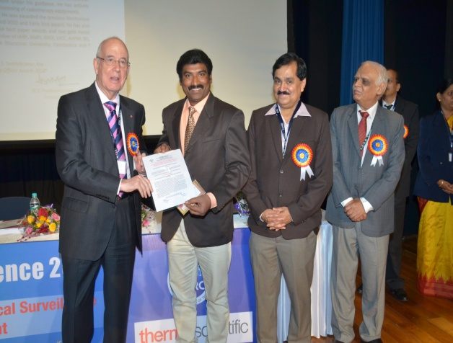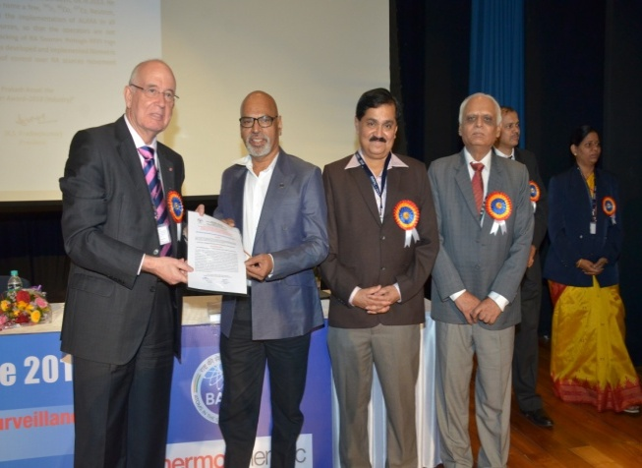

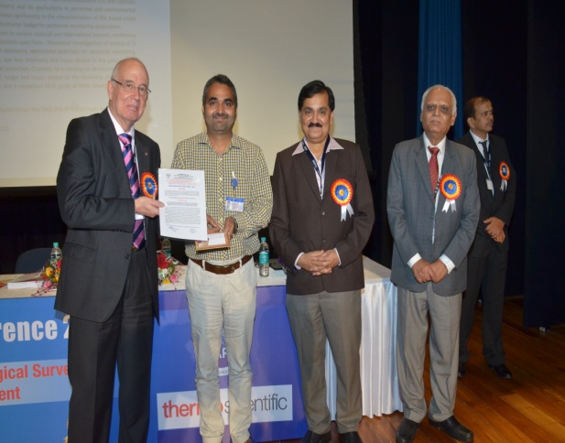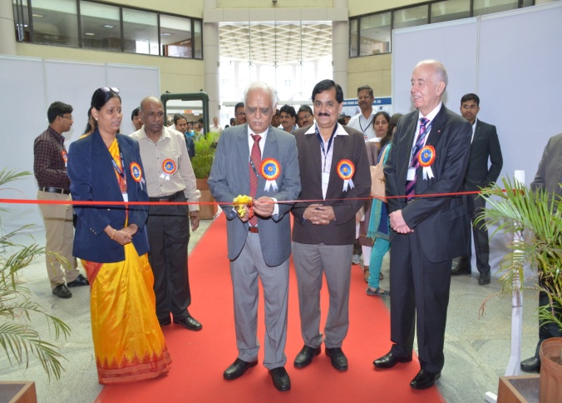

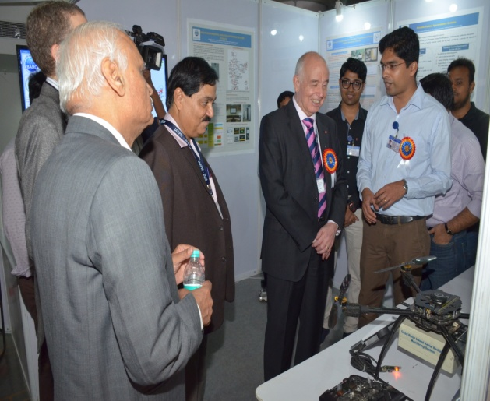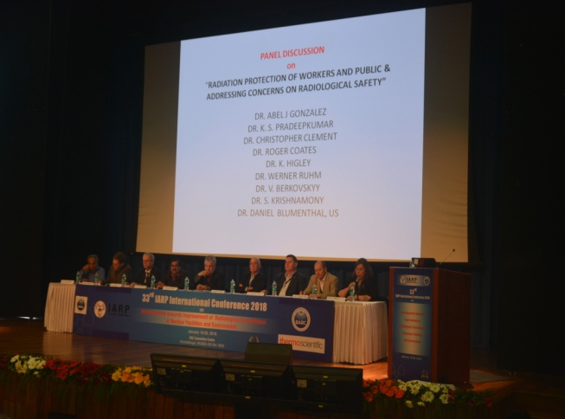

Dr. A. K. Ganguly Birth Centenary Year and Felicitation of Senior Life Members of IARP during the Golden Jubilee Year Celebrations
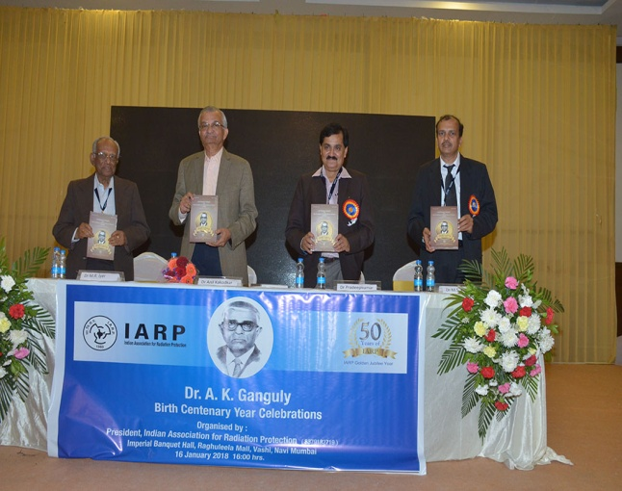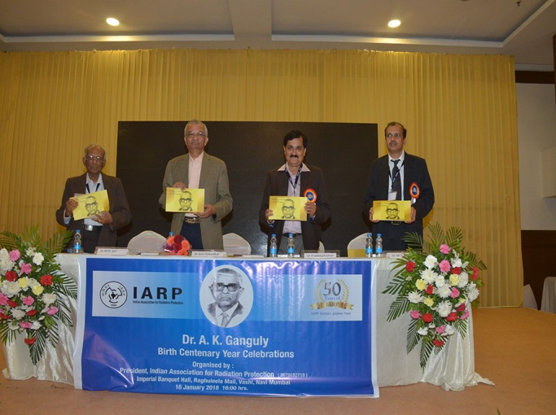

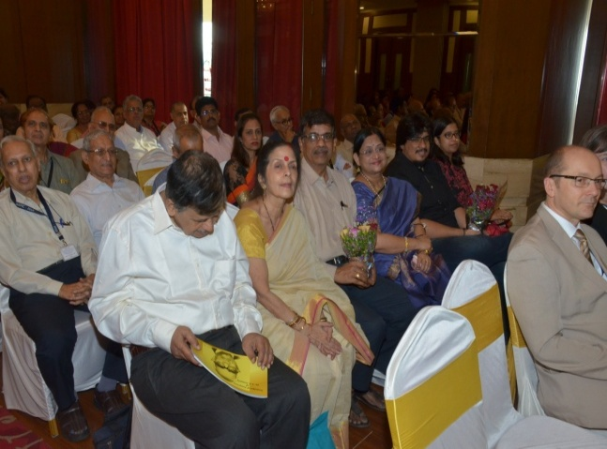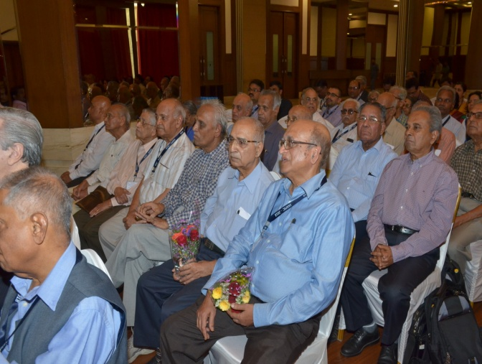

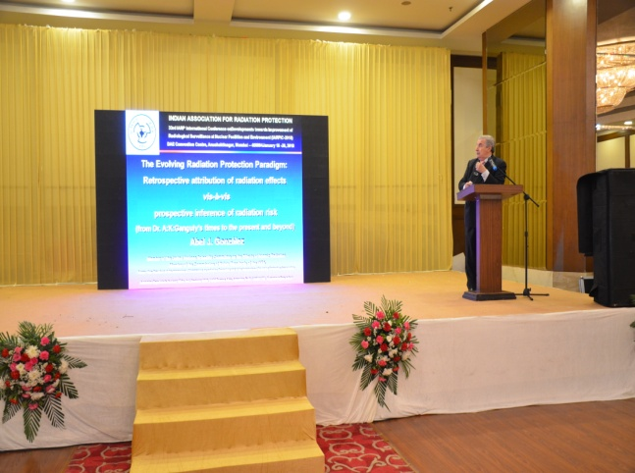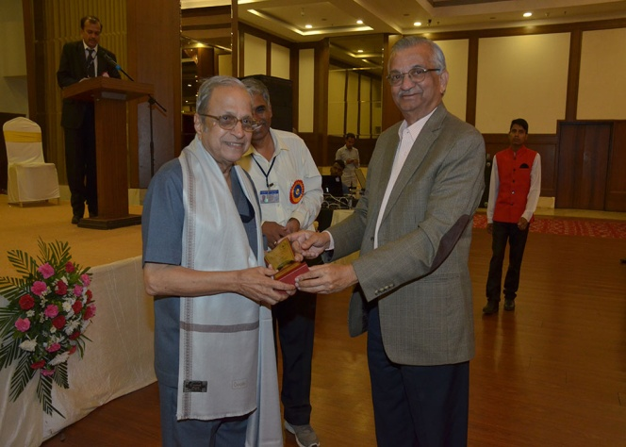

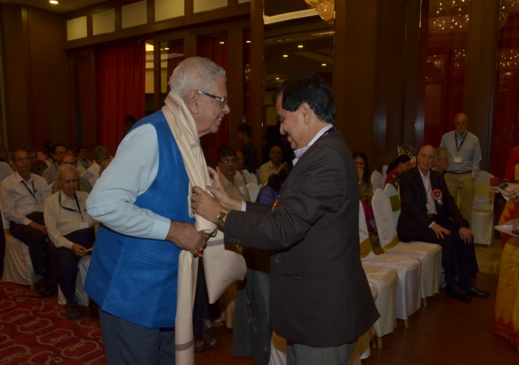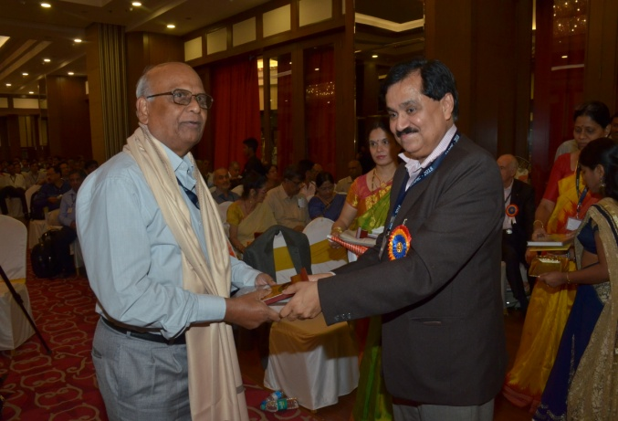
Public Awareness Programmes conducted by IARP
during 2017-2018

